CHESS GAME USING PYTHON

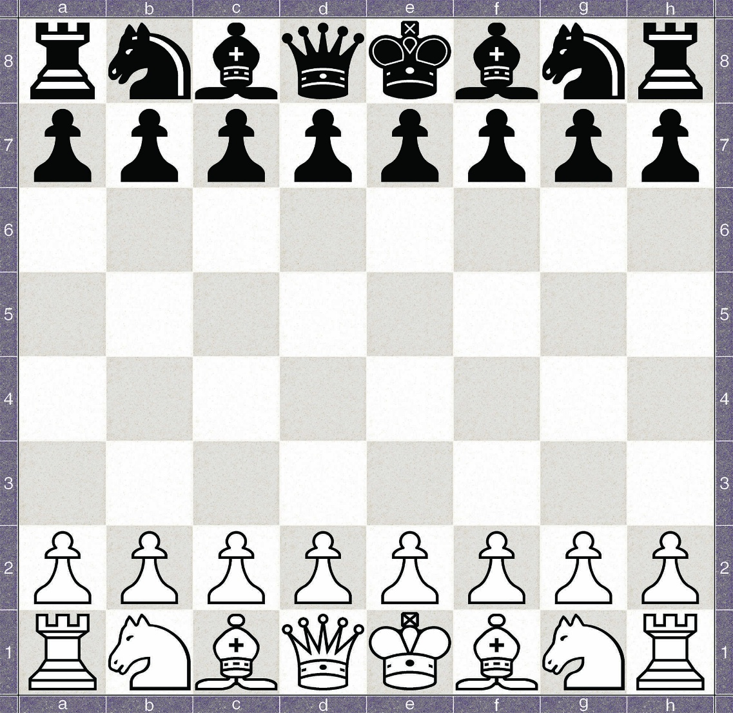

* Chess is played by two players on a chess board measuring eight-by-eight squares. The 64 squaresAlternate between light and dark colours – traditionally, black and white. When properly set up, a white Square should be the rightmost square along the edge closest to each player.
* Basic chess rules
* In chess, each player takes turns to make a single move. Players cannot choose to skip a turn - they must
* move a piece. Each chess piece moves in a specific way, and must be moved according to its legal
* movement.
* Except for the knight, which may jump over pieces, pieces cannot move through pieces of either colour
* without either stopping (in the same of a piece of the same colour) or capturing them (in the case of a piece of the opposite colour)

**Source code:-**

import **itertools**

WHITE = "white"

BLACK = "black"

class **Game**:

*#ive decided since the number of pieces is capped but the type of pieces is not (pawn transformations), I've already coded much of the modularity to support just using a dictionary of pieces*

    def **__init__**(self):

        self.playersturn = BLACK

        self.Message = "this is where prompts will go"

        self.gameboard = {}

        self.**placePieces**()

**print**("chess program. enter moves in algebraic notation separated by space")

        self.**main**()

    def **placePieces**(self):

        for i in **range**(0,8):

            self.gameboard[(i,1)] = **Pawn**(WHITE,uniDict[WHITE][**Pawn**],1)

            self.gameboard[(i,6)] = **Pawn**(BLACK,uniDict[BLACK][**Pawn**],-1)

        placers = [**Rook**,**Knight**,**Bishop**,**Queen**,**King**,**Bishop**,**Knight**,**Rook**]

        for i in **range**(0,8):

            self.gameboard[(i,0)] = placers[i](WHITE,uniDict[WHITE][placers[i]])

            self.gameboard[((7-i),7)] = placers[i](BLACK,uniDict[BLACK][placers[i]])

        placers.**reverse**()

    def **main**(self):

        while True:

            self.**printBoard**()

**print**(self.message)

            self.message = ""

            startpos,endpos = self.**parseInput**()

            try:

                target = self.gameboard[startpos]

            except:

                self.message = "could not find piece; index probably out of range"

                target = None

            if target:

**print**("found "+**str**(target))

                if target.Color != self.playersturn:

                    self.message = "you aren't allowed to move that piece this turn"

                    continue

                if target.isValid(startpos,endpos,target.Color,self.gameboard):

                    self.message = "that is a valid move"

                    self.gameboard[endpos] = self.gameboard[startpos]

                    del self.gameboard[startpos]

                    self.**isCheck**()

                    if self.playersturn == BLACK:

                        self.playersturn = WHITE

                    else : self.playersturn = BLACK

                else :

                    self.message = "invalid move" + **str**(target.availableMoves(startpos[0],startpos[1],self.gameboard))

**print**(target.availableMoves(startpos[0],startpos[1],self.gameboard))

            else : self.message = "there is no piece in that space"

    def **isCheck**(self):

*#ascertain where the kings are, check all pieces of opposing color against those kings, then if either get hit, check if its checkmate*

        king = **King**

        kingDict = {}

        pieceDict = {BLACK : [], WHITE : []}

        for position,piece in self.gameboard.**items**():

            if **type**(piece) == **King**:

                kingDict[piece.Color] = position

**print**(piece)

            pieceDict[piece.Color].**append**((piece,position))

*#white*

        if self.**canSeeKing**(kingDict[WHITE],pieceDict[BLACK]):

            self.message = "White player is in check"

        if self.**canSeeKing**(kingDict[BLACK],pieceDict[WHITE]):

            self.message = "Black player is in check"

    def **canSeeKing**(self,kingpos,piecelist):

*#checks if any pieces in piece list (which is an array of (piece,position) tuples) can see the king in kingpos*

        for piece,position in piecelist:

            if piece.isValid(position,kingpos,piece.Color,self.gameboard):

                return True

    def **parseInput**(self):

        try:

            a,b = **input**().**split**()

            a = ((**ord**(a[0])-97), **int**(a[1])-1)

            b = (**ord**(b[0])-97, **int**(b[1])-1)

**print**(a,b)

            return (a,b)

        except:

**print**("error decoding input. please try again")

            return((-1,-1),(-1,-1))

    def **printBoard**(self):

**print**("  1 | 2 | 3 | 4 | 5 | 6 | 7 | 8 |")

        for i in **range**(0,8):

**print**("-"*32)

**print**(**chr**(i+97),end="|")

            for j in **range**(0,8):

                item = self.gameboard.**get**((i,j)," ")

**print**(**str**(item)+' |', end = " ")

**print**()

**print**("-"*32)

class **Piece**:

    def **__init__**(self,color,name):

        self.name = name

        self.position = None

        self.Color = color

    def **isValid**(self,startpos,endpos,Color,gameboard):

        if endpos in self.**availableMoves**(startpos[0],startpos[1],gameboard, Color = Color):

            return True

        return False

    def **__repr__**(self):

        return self.name

    def **__str__**(self):

        return self.name

    def **availableMoves**(self,x,y,gameboard):

**print**("ERROR: no movement for base class")

    def **AdNauseum**(self,x,y,gameboard, Color, intervals):

        answers = []

        for xint,yint in intervals:

            xtemp,ytemp = x+xint,y+yint

            while self.**isInBounds**(xtemp,ytemp):

*#print(str((xtemp,ytemp))+"is in bounds")*

                target = gameboard.get((xtemp,ytemp),None)

                if target is None: answers.**append**((xtemp,ytemp))

                elif target.Color != Color:

                    answers.**append**((xtemp,ytemp))

                    break

                else:

                    break

                xtemp,ytemp = xtemp + xint,ytemp + yint

        return answers

    def **isInBounds**(self,x,y):

        "checks if a position is on the board"

        if x >= 0 and x < 8 and y >= 0 and y < 8:

            return True

        return False

    def **noConflict**(self,gameboard,initialColor,x,y):

        "checks if a single position poses no conflict to the rules of chess"

        if self.**isInBounds**(x,y) and (((x,y) not in gameboard) or gameboard[(x,y)].Color != initialColor) : return True

        return False

chessCardinals = [(1,0),(0,1),(-1,0),(0,-1)]

chessDiagonals = [(1,1),(-1,1),(1,-1),(-1,-1)]

def **knightList**(x,y,int1,int2):

    """sepcifically for the rook, permutes the values needed around a position for noConflict tests"""

    return [(x+int1,y+int2),(x-int1,y+int2),(x+int1,y-int2),(x-int1,y-int2),(x+int2,y+int1),(x-int2,y+int1),(x+int2,y-int1),(x-int2,y-int1)]

def **kingList**(x,y):

    return [(x+1,y),(x+1,y+1),(x+1,y-1),(x,y+1),(x,y-1),(x-1,y),(x-1,y+1),(x-1,y-1)]

class **Knight**(**Piece**):

    def **availableMoves**(self,x,y,gameboard, Color = None):

        if Color is None : Color = self.Color

        return [(xx,yy) for xx,yy in **knightList**(x,y,2,1) if self.**noConflict**(gameboard, Color, xx, yy)]

class **Rook**(**Piece**):

    def **availableMoves**(self,x,y,gameboard ,Color = None):

        if Color is None : Color = self.Color

        return self.**AdNauseum**(x, y, gameboard, Color, chessCardinals)

class **Bishop**(**Piece**):

    def **availableMoves**(self,x,y,gameboard, Color = None):

        if Color is None : Color = self.Color

        return self.**AdNauseum**(x, y, gameboard, Color, chessDiagonals)

class **Queen**(**Piece**):

    def **availableMoves**(self,x,y,gameboard, Color = None):

        if Color is None : Color = self.Color

        return self.**AdNauseum**(x, y, gameboard, Color, chessCardinals+chessDiagonals)

class **King**(**Piece**):

    def **availableMoves**(self,x,y,gameboard, Color = None):

        if Color is None : Color = self.Color

        return [(xx,yy) for xx,yy in **kingList**(x,y) if self.**noConflict**(gameboard, Color, xx, yy)]

class **Pawn**(**Piece**):

    def **__init__**(self,color,name,direction):

        self.name = name

        self.Color = color

*#of course, the smallest piece is the hardest to code. direction should be either 1 or -1, should be -1 if the pawn is traveling "backwards"*

        self.direction = direction

    def **availableMoves**(self,x,y,gameboard, Color = None):

        if Color is None : Color = self.Color

        answers = []

        if (x+1,y+self.direction) in gameboard and self.**noConflict**(gameboard, Color, x+1, y+self.direction) : answers.**append**((x+1,y+self.direction))

        if (x-1,y+self.direction) in gameboard and self.**noConflict**(gameboard, Color, x-1, y+self.direction) : answers.**append**((x-1,y+self.direction))

        if (x,y+self.direction) not in gameboard and Color == self.Color : answers.**append**((x,y+self.direction))*# the condition after the and is to make sure the non-capturing movement (the only fucking one in the game) is not used in the calculation of checkmate*

        return answers

uniDict = {WHITE : {**Pawn** : "♙", **Rook** : "♖", **Knight** : "♘", **Bishop** : "♗", **King** : "♔", **Queen** : "♕" }, BLACK : {**Pawn** : "♟", **Rook** : "♜", **Knight** : "♞", **Bishop** : "♝", **King** : "♚", **Queen** : "♛" }}

**Game**()

OUTPUT:

